Swimlane Diagrams

Use Case 1: Create a personal checking account
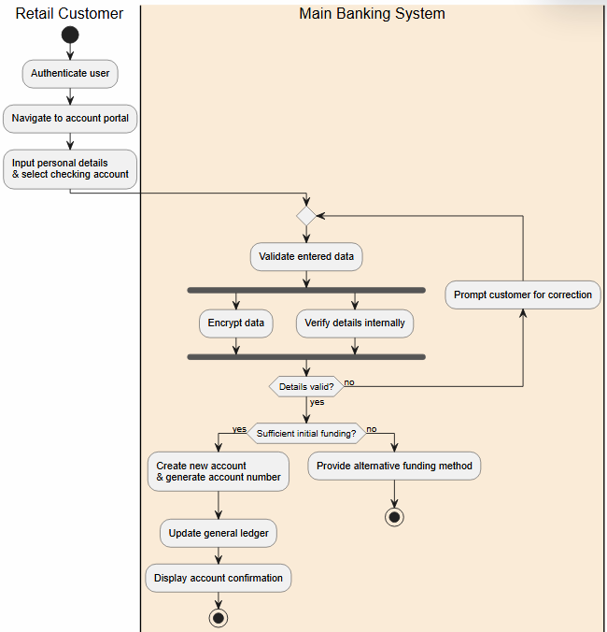
Use Case 2: Initiate Bulk Payroll processing

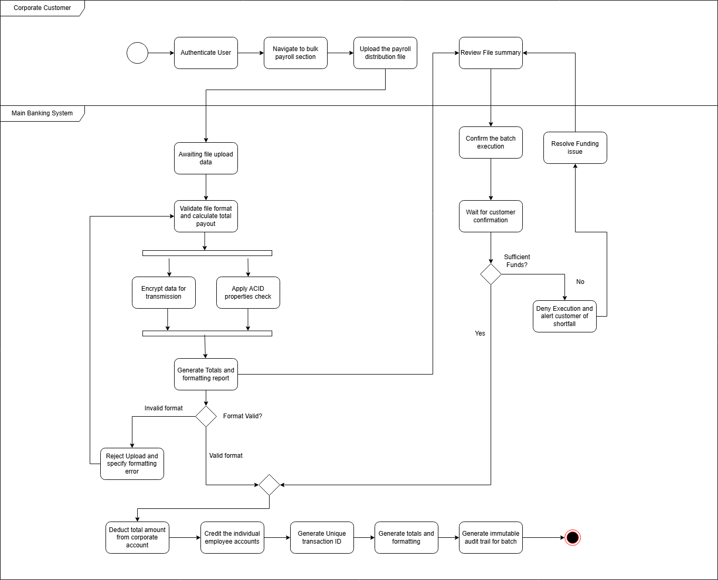
Use Case 3: Manage Multiple Authorized Signers
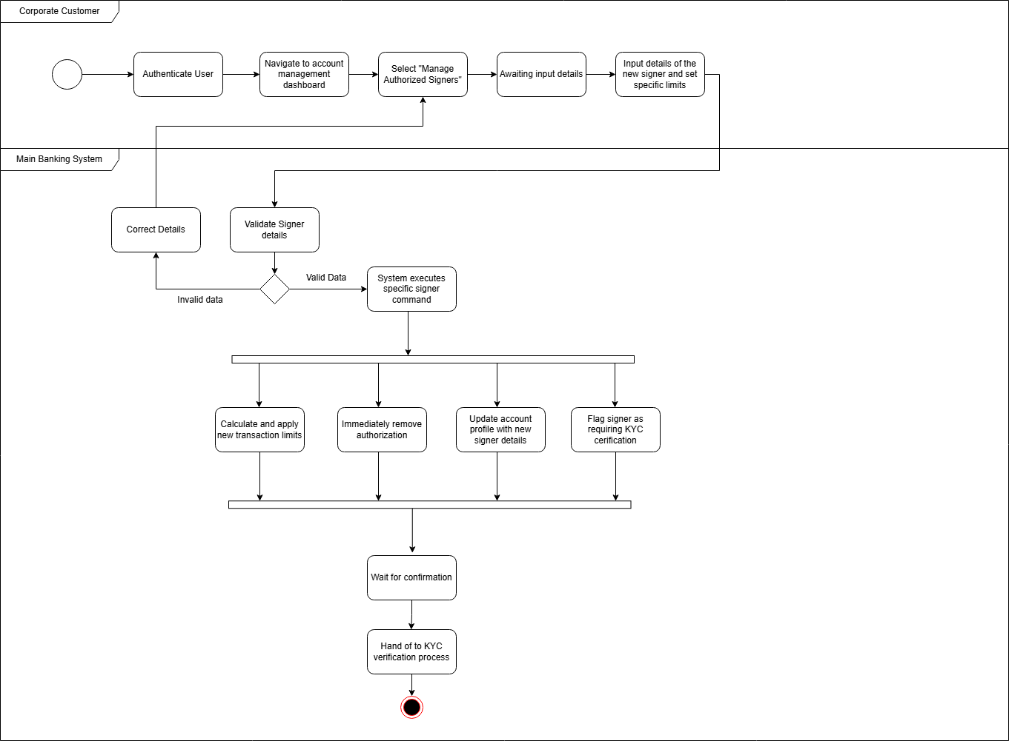
Use Case 4: Update KYC Documents
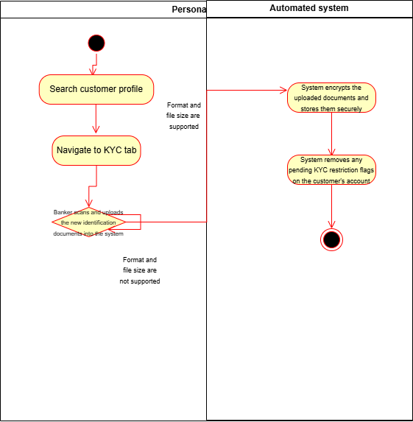
Use Case 5: Manage User Accounts (HR)
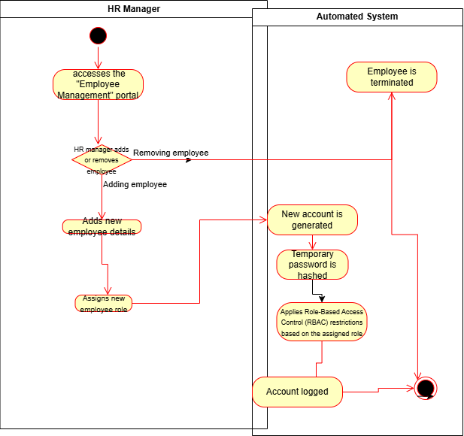
Use Case 6: Process Cash transactions (Deposit and Withdraw)
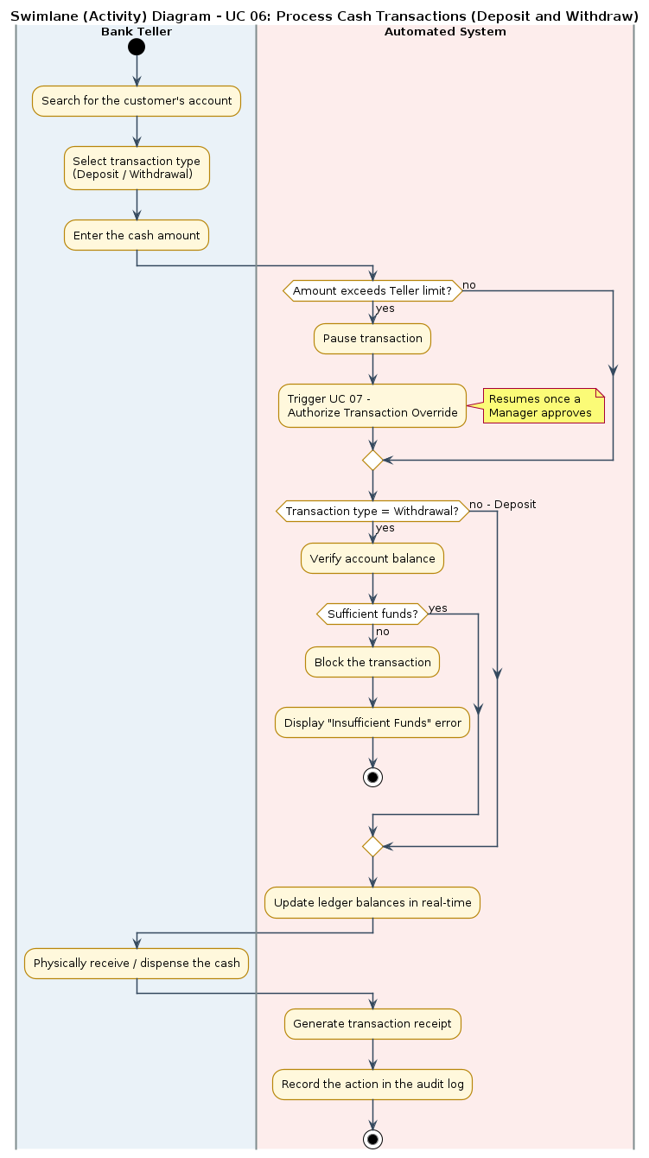

Use Case 7: Authorize Transaction Overrides
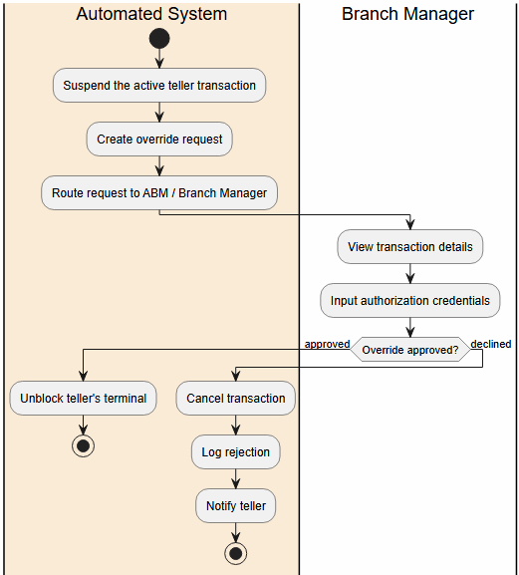
Use Case 8: Manage Branch Cash and Vault Operations
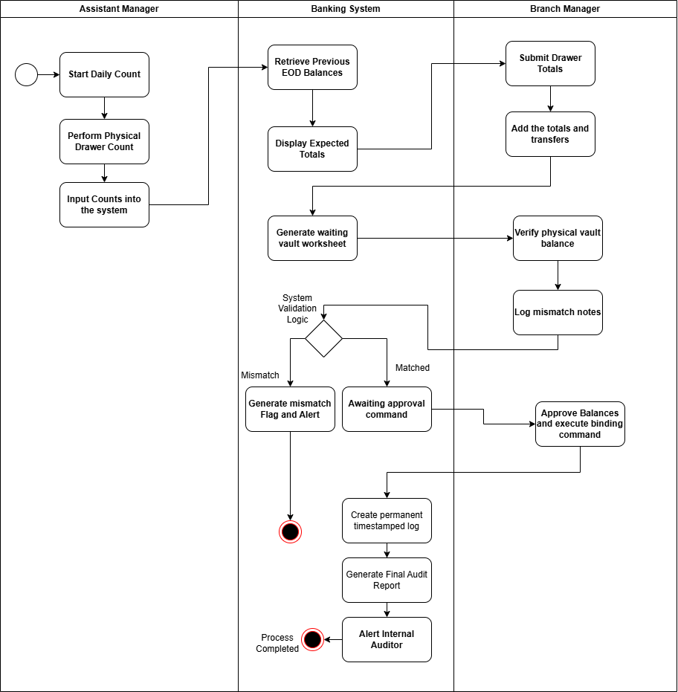
Use Case 9: Settle External Transfers
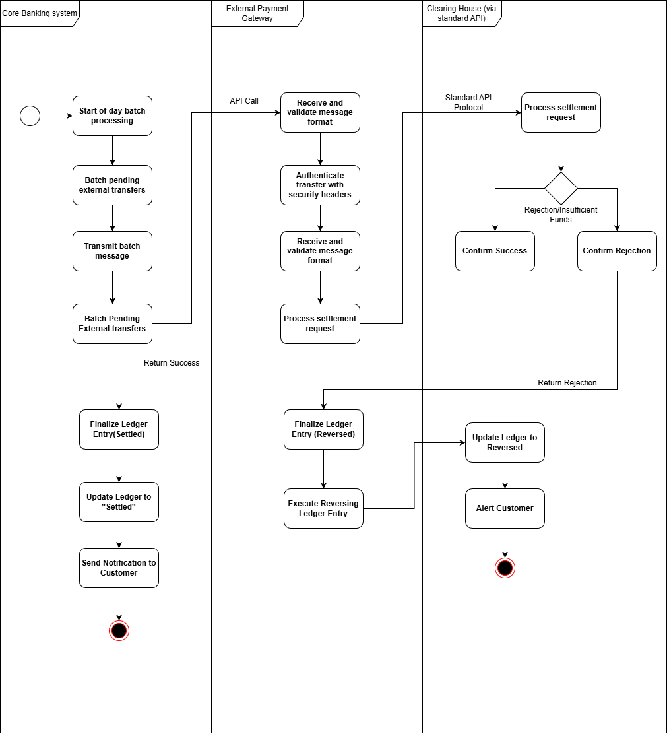
Use Case 10: Evaluate Loan Applications
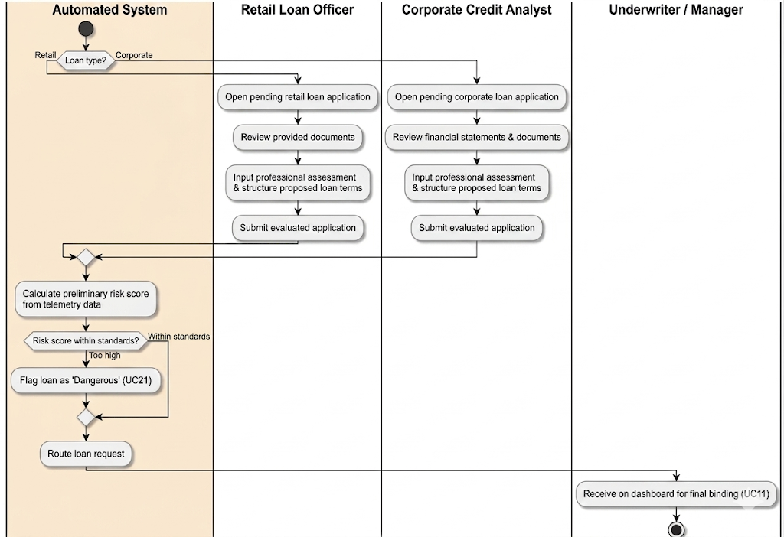
Use Case 11: Underwrite and Bind Loan Agreement

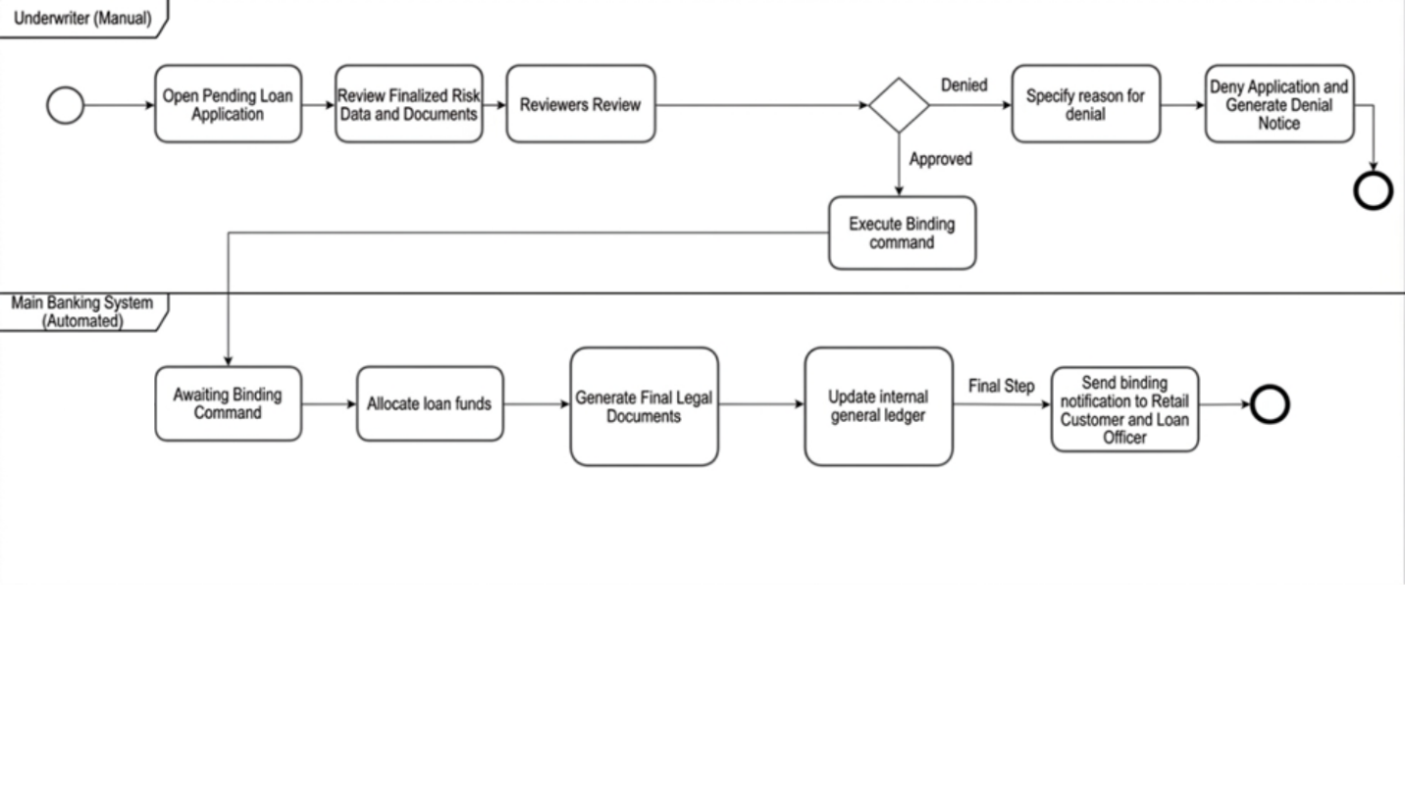

Use Case 12: Manage Defaulted Accounts and Asset Recovery
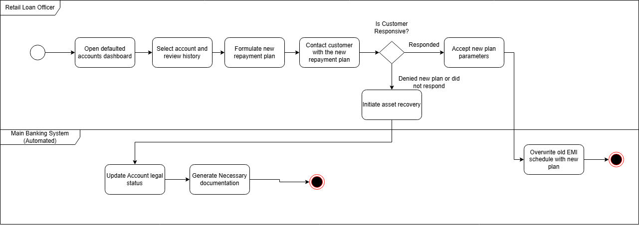
Use Case 13: UC 13 Monitor Transactions and Generate AML Reports
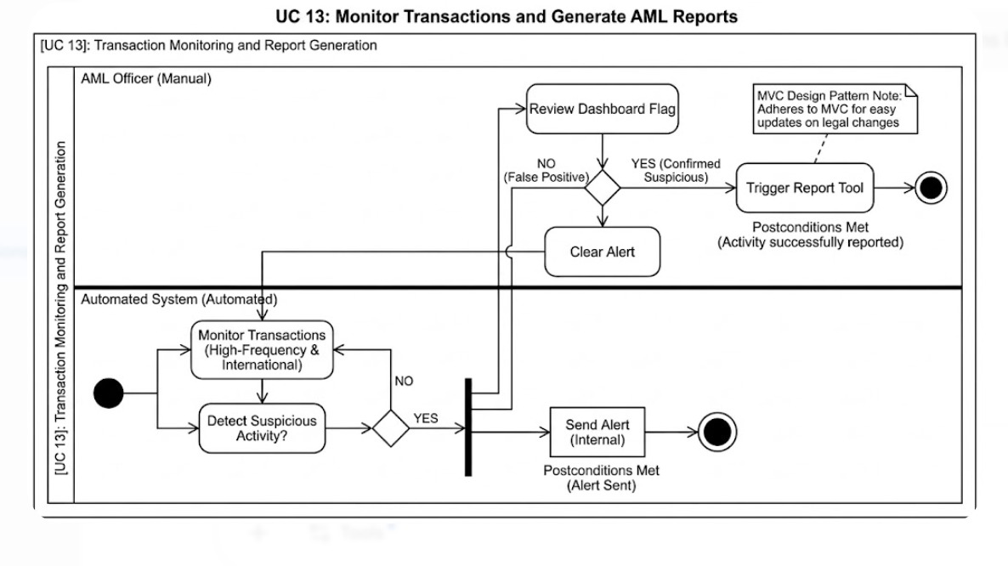
Use Case 14: View Action History and Audit Logs
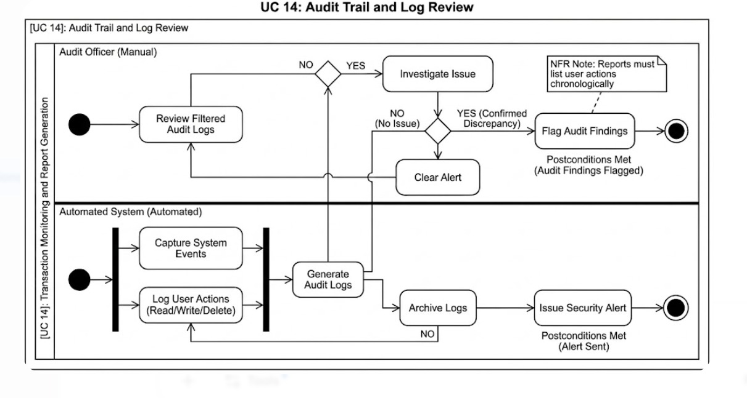
Use Case 15: View Profitability and Transaction Summaries
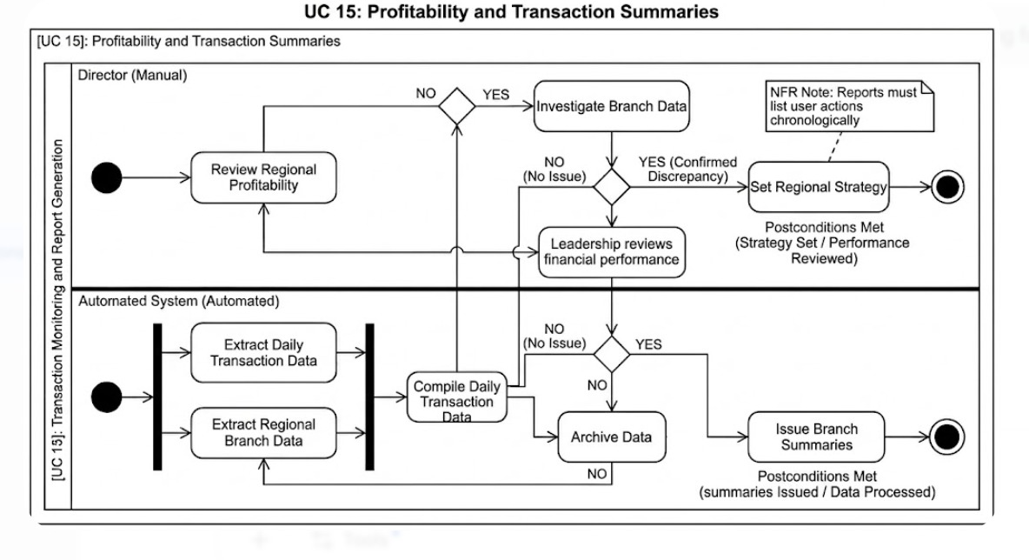
Use Case 16: Manage Core System Configurations and Backups
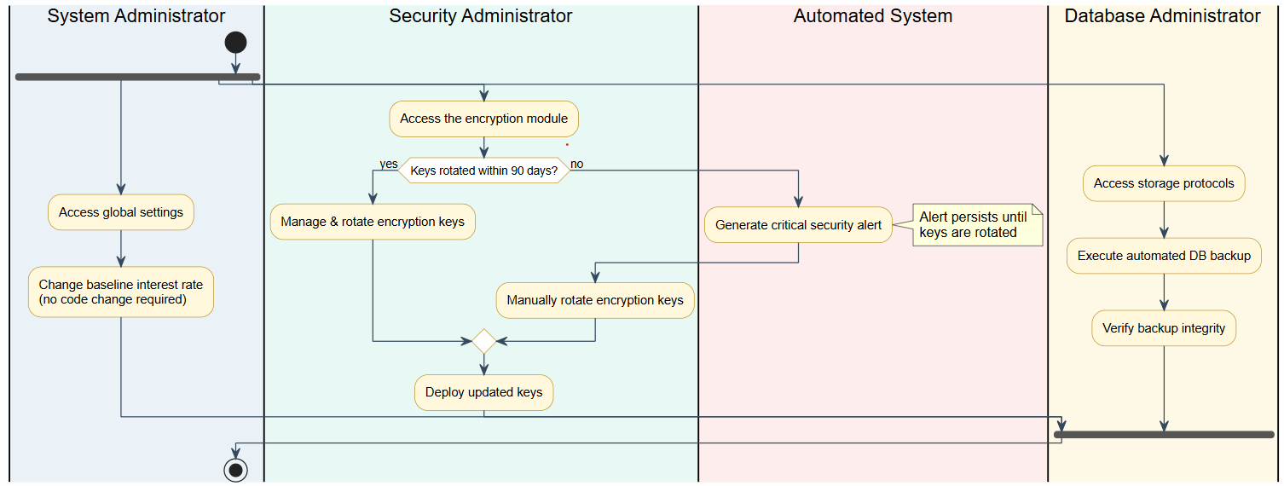
Use Case 17: Generate Account Statements
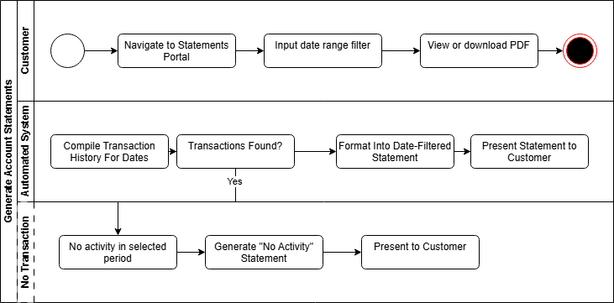
Use Case 18: Issue New Debit Card
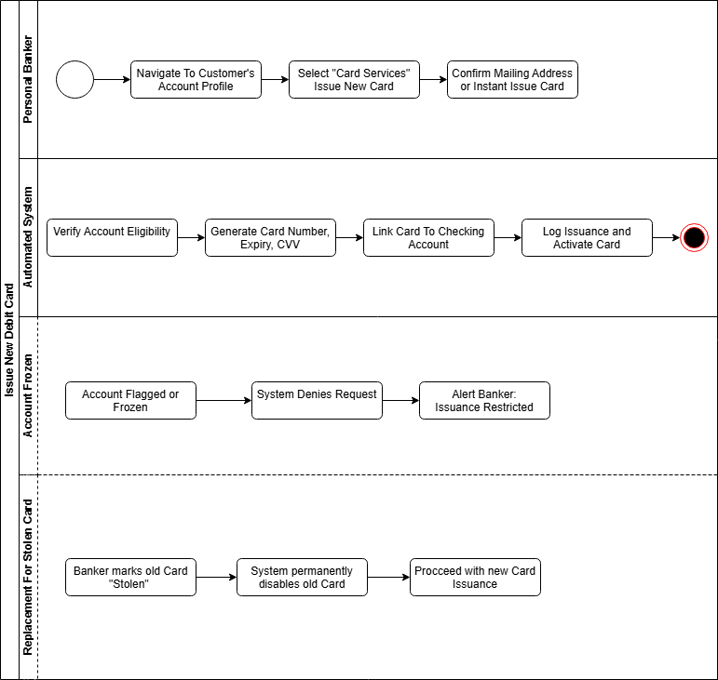
Use Case 19: Authenticate User
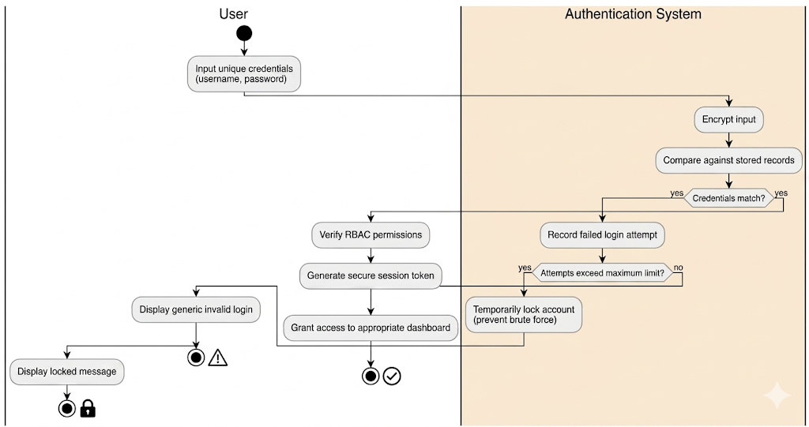
Use Case 20: Set Global Risk Parameters
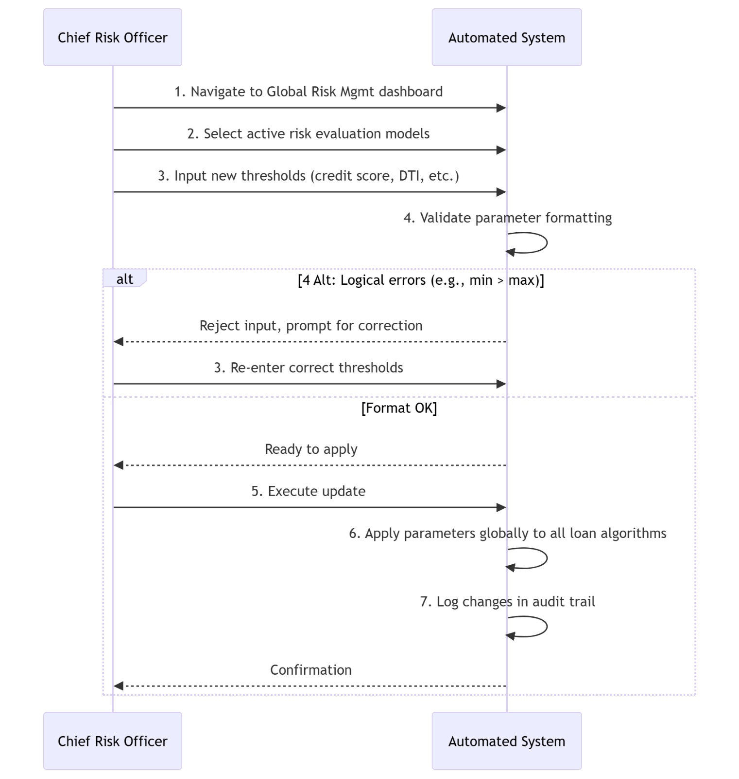
Use Case 21: Flag Dangerous Loans
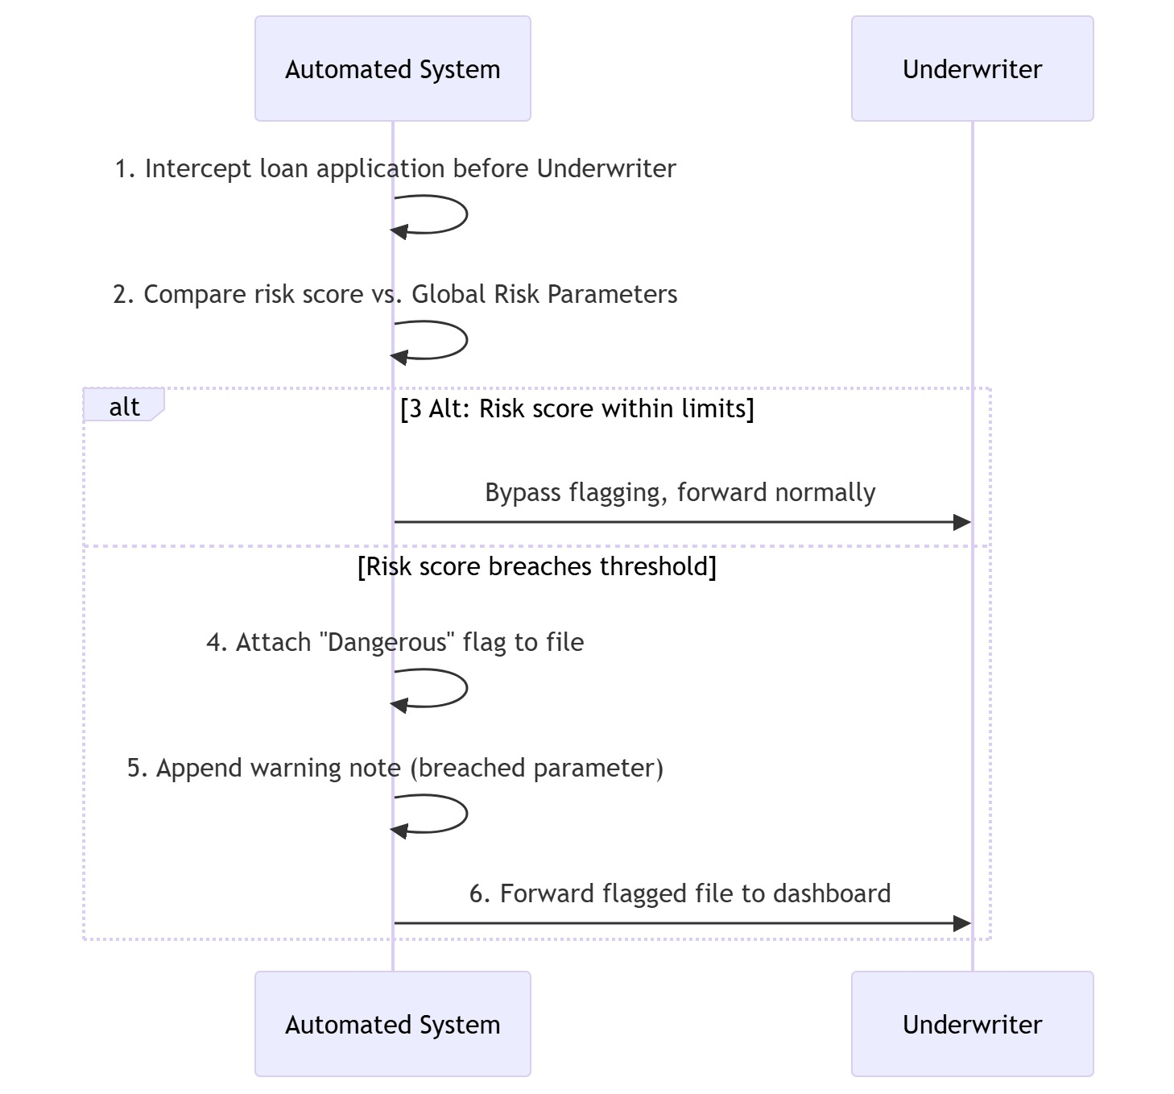
Use Case 22: Route Loan Requests
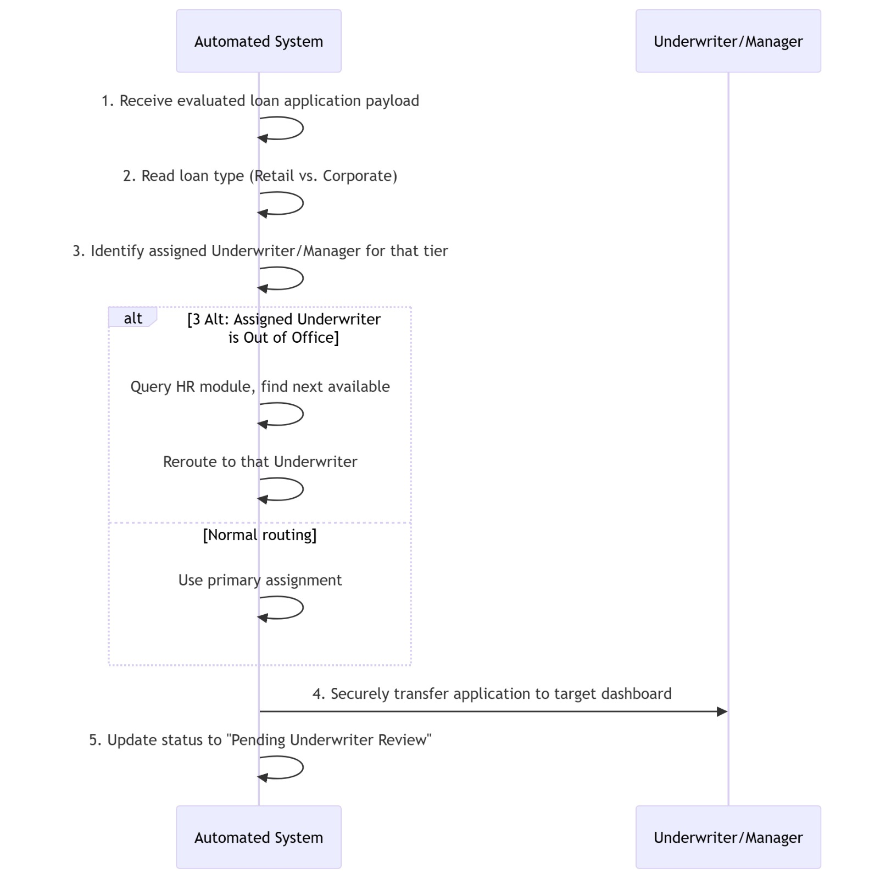
Use Case 23: Update Ledger Balances in Real-Time
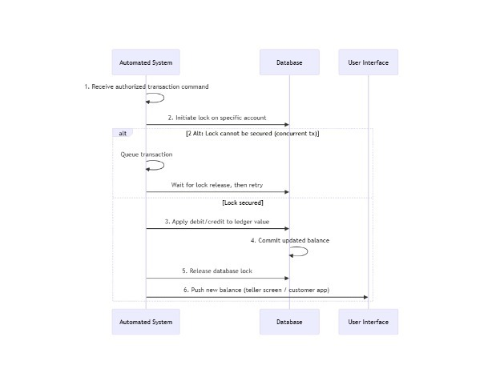

Use Case 24: Generate Daily Transaction Summaries

